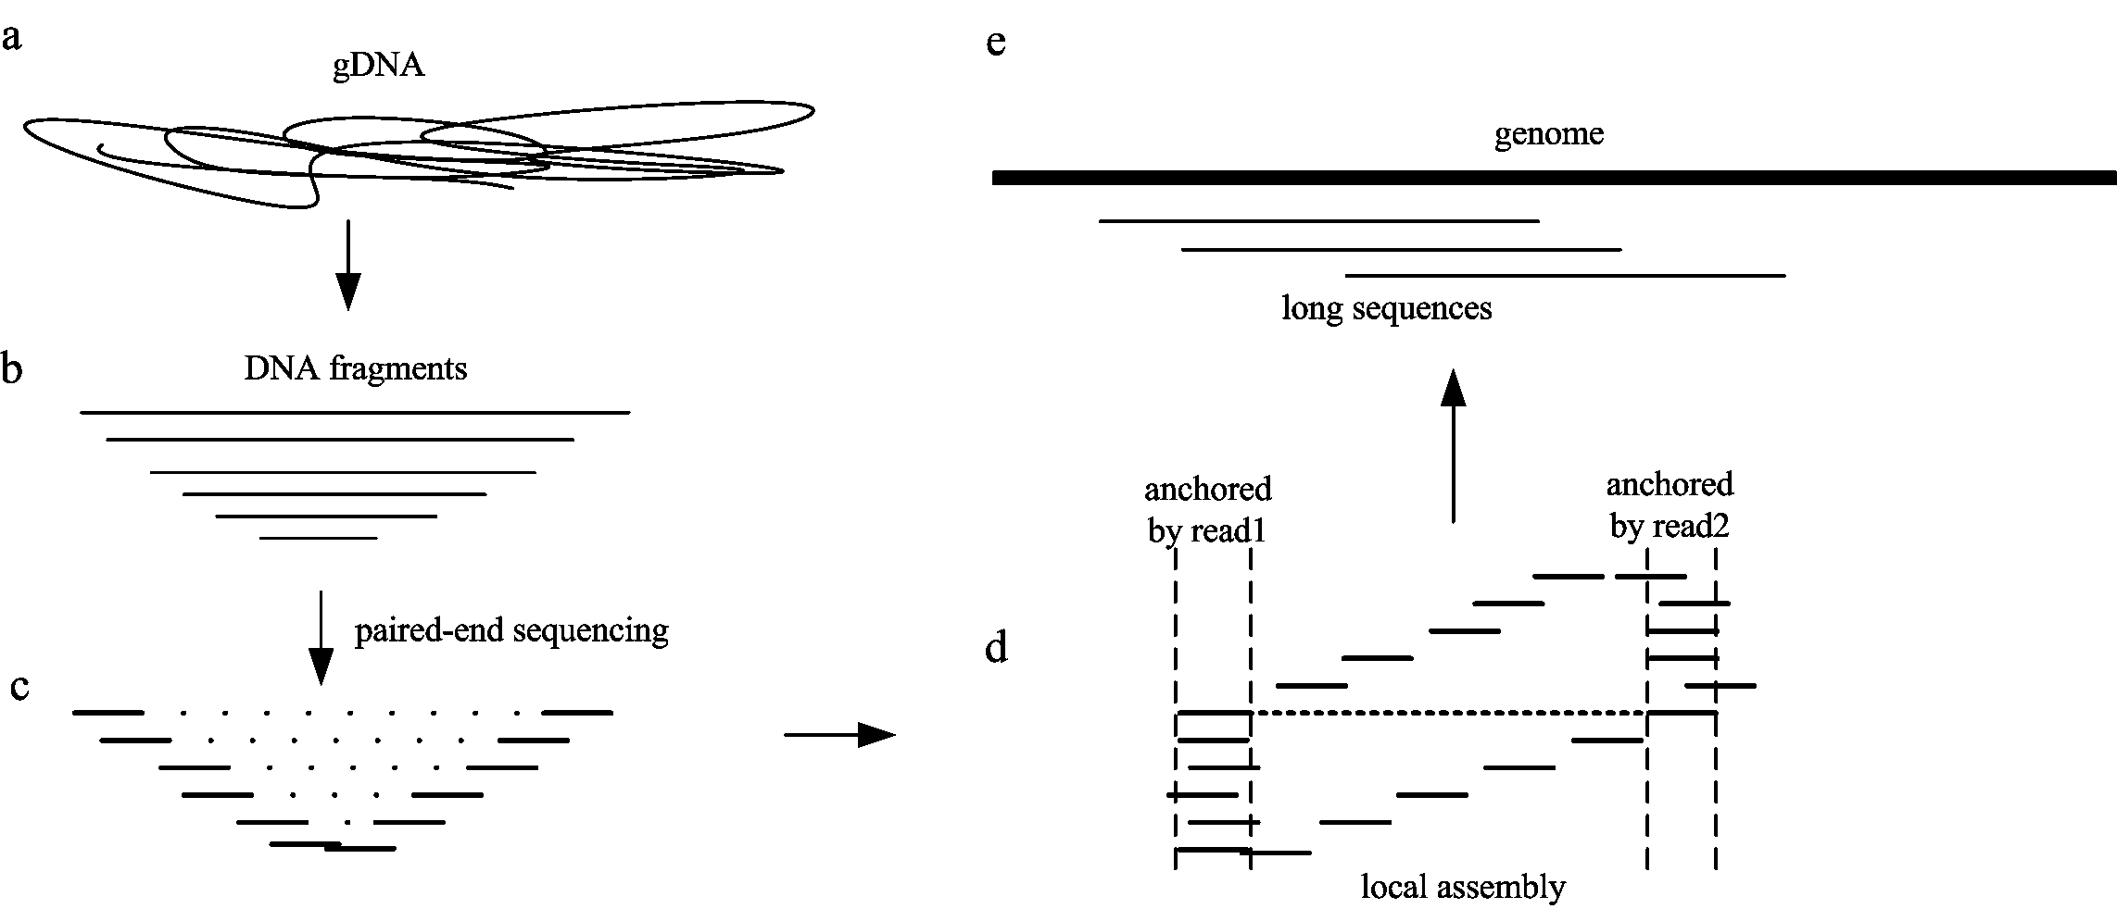
Figure 1 | A schematic overview of the sequencing and tag-free local assembly. (a) Genomic DNA was extracted from w1118 D. mel line. (b) gDNA was randomly sheared into a smear of DNA fragments, and separately sent to library preparation. (c) After paired-end sequencing, read pairs with continuous insert sizes were generated. (d) Internal gap of SR2 were filled with reads from SR1. First, we grouped SR1 which computationally overlapped with either ends for each SR2. Then a string graph of grouped reads in bold was built. A serial of arrawed lines demonstrated the path of long sequence construction. (e) Long sequences randomly laid on genome as the original SR2.

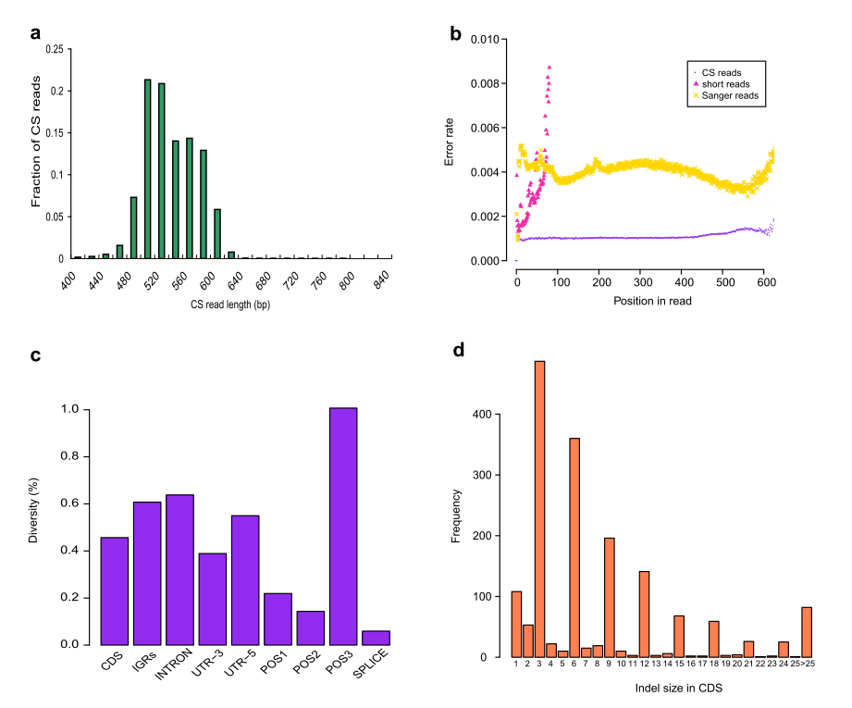
Figure 2 | Evaluation of assembled CS reads. (a) Histogram of assembled CS read length (bin size 20 bp). (b) Error rate comparison as read positions among assembled CS reads, short reads and Sanger sequences. Read length was limited within 600 bp. (c) Diversity estimation of the sequenced w1118 line in different genomic regions after SNP analysis of CS reads. The level of diversity among those regions consists with previous data. (d) Apparent evidence for indel size of multiple three in coding sequences (CDS) after indel calling for CS reads using SAMtools.

